**Ain Shams University**  
**Faculty of Computer & Information Sciences**

**Computer Science Department**

**Neural Network Project Report**

**Selected Project Idea:**

**“Weather Analysis Using Image Recognition”**



Under Supervision of:

**Dr. Ghada Hamed**

**Team Members:**

**1st** Team Member Name:

**Kareem Sherif Fathy**

**1st** Team Member ID:

2018170283

**2nd** Team Member Name:

**Kareem Saeed Ragab**

**2nd** Team Member ID:

2018170282

**3rd** Team Member Name:

**Abanoub Asaad Azab**

**3rd** Team Member ID:

2018170001

**4th** Team Member Name:

**Nada El Sayed Anies**

**4th** Team Member ID:

2018170430

**5th** Team Member Name:

**Nada Mohamed Abdelhamed**

**5th** Team Member ID:

2018170434

**1**

**Trial #1:** “Encoder & Decoder Model”

* 1. **Model Architecture**

The model architecture consists of some Convolution layers followed by Batch Normalization layers followed by Max Pooling Layers. This step names Encoder (Down Sampling) Step. After this, the architecture reverse all the steps such as: any convolution layers replace it with Un-convolution layers and any Pooling Layers will replace it with Un-Pooling Layers. This step names Decoder (Up Sampling) Step. It still reverse until the image size make as the original size.

**The below architecture prove that:**

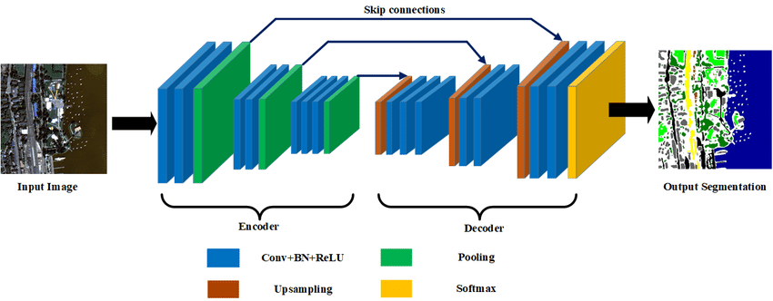

**2**

* 1. **The tried model architecture in details**

The architecture consists of 7 convolution & Batch Normalization & Max pooling layers with kernel size (3, 3) and same Padding and **relu** activation function. Then Up Sampling layer. Then reversed 7 un-convolution & Batch Normalization & un-Pooling layers with kernel size (3, 3) and same Padding and **relu** activation function. Followed by Flatten Layer followed Dense and the last Dense layer with **softmax** activation function layer with 11 output class.

* 1. **The used Techniques**
* Label Encoder
* One Hot Encoder

**1.4 The Model Validation Loss and Accuracy**

* validation loss: **60.6%**
* validation accuracy: **54.2%**

**1.5 Trial Conclusion**

The model without normalization that this effects on the training. Also the model without data augmentation and this effects on the size of the data and types of augmentation techniques such as (scaling, zooming, lighting,…).

**3**

**Trial #2:** “Alex Net Model”

* 1. **Model Architecture**

The model architecture is a sequential model that consists of some convolution layers followed by Batch Normalization layers followed by Max Pooling Layers. Followed by 2 Dense (Fully connected) layers.

**The below architecture prove that:**

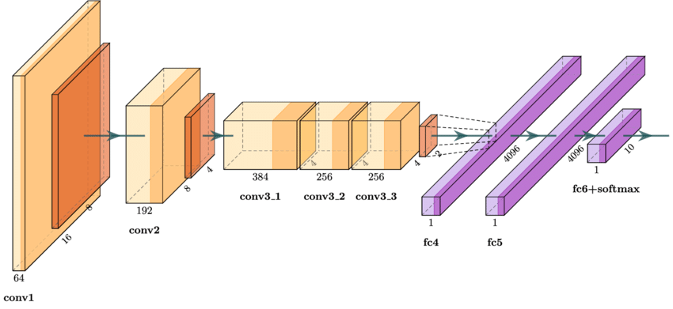

**4**

* 1. **The tried model architecture in details**

The architecture consists of 5 convolution & Batch Normalization & Max pooling layers with kernel size (3, 3) and same Padding and **relu** activation function. Followed by Flatten Layer followed 2 Dense layer and the last Dense layer with **softmax** activation function with 11 output class.

* 1. **The used Techniques**
* Label Encoder
* One Hot Encoder

**1.4 The Model Validation Loss and Accuracy**

* validation loss: **15.6%**
* validation accuracy: **75.7%**

**1.5 Trial Conclusion**

The model has a small number of layers lead to that the model doesn’t learn well to classify the weather result. It also without normalization that this effects on the training. Also the model without data augmentation and this effects on the size of the data and types of augmentation techniques such as (scaling, zooming, lighting,…).

**5**